**Parent Access to Canvas on an iPhone**

1. Go to the app store on your iPhone and search for the **Canvas Parent** app. Then tap **Get** and the app will download to your iPhone.

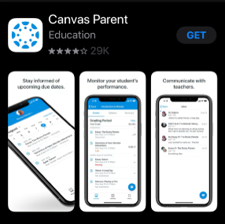

1. Tap Open and the Parent app will open.

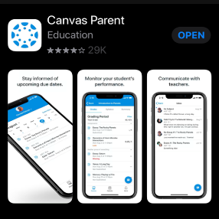

1. Once the app is Open, click **Find School**. On the next screen type in Roanoke. A list of options will show. Choose the **Roanoke Parents (VA)** option.

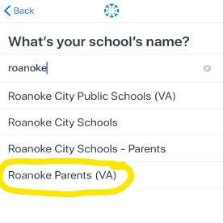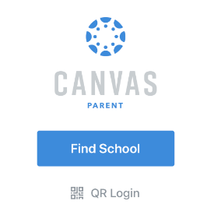

1. 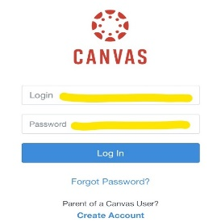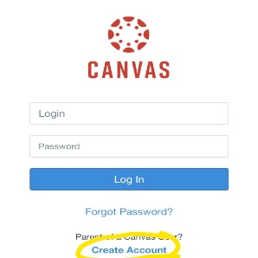If you do not already have a login for Canvas, choose create account. You will need your student’s **pairing code** to create an account. Then you can login with your **email and password**.
2. After you have logged in, you will see a list of the student courses your child is enrolled in.

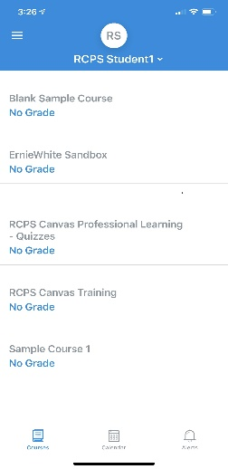

1. 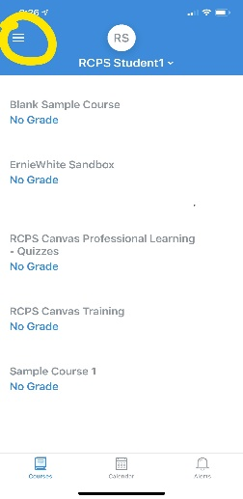If you have more than one child in RCPS, tap on the **menu** in the top left of the page. On the next page, **tap the + sign**. The **Add Student** screen will appear. Use the pairing code for your other child to add them to the Canvas Parent app.

